1. Use the previous Ubuntu version and cuda version. We have upgraded to Ubuntu 18.04 and cuda 10.0.
2. Install Pycharm from ubuntu software centre.
3. After installing import our Project folder. If you import correctly you will see the following window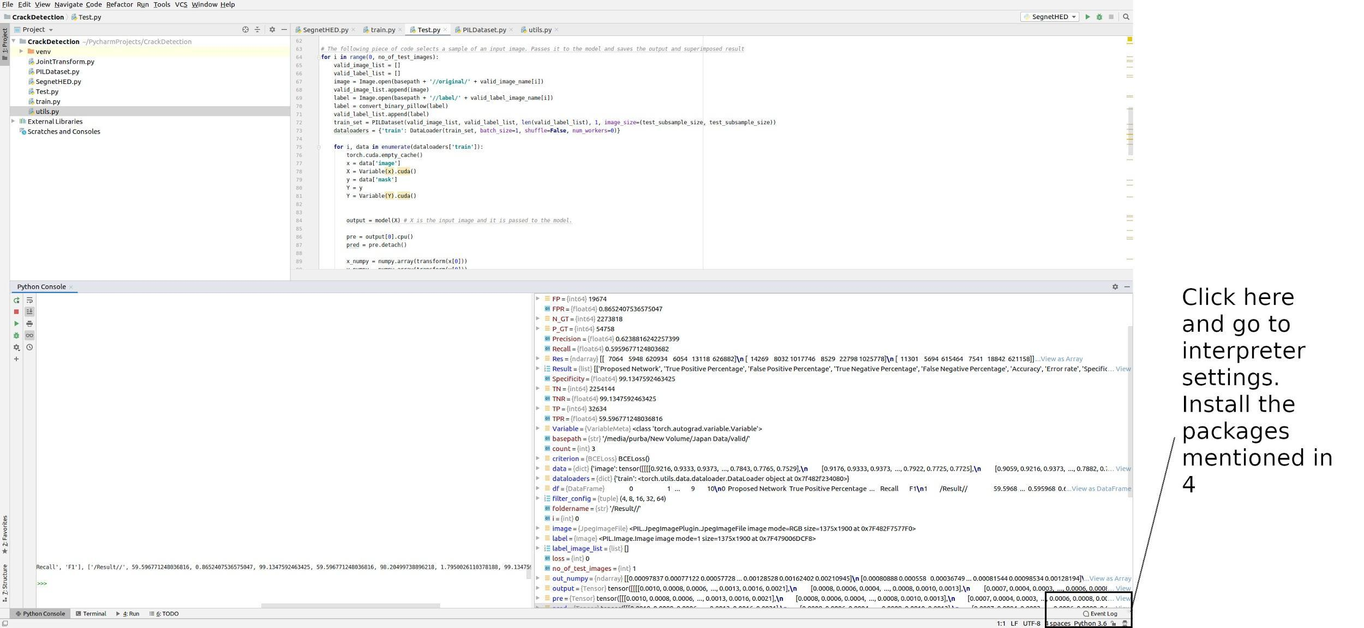
4. You need to install the following packages :

* **torch**
* **torchsummary**
* **torchvision**
* **scikit-image**
* **Pillow**
* **openpyxl**
* **pandas**
* **tensorboardX**
* **opencv-python**
* collections
* copy
* time

1. There are five scripts included in the project. To test the model you need to run Test.py
2. You have to fix the filepaths before running the command. The filepaths are mentioned in the Test.py code.
3. You have to arrange the data in the following manner:

----data

---valid

--original

--label

--Result

1. Please don't try to change or run other codes. That might give you errors. We will upload an instance of the data folder. Moreover, carefully follow the instruction inside code Test.py before running.
2. If you have any problem installing pycharm or running the code let us know

**Training Instructions.**

1. **For training you need to run train.py script. You have to arrange the folders in the following manner :**

**JapanData--**

**---train**

--original

--label

--Result

**---valid**

--original

--label

--Result

1. **You need to change the folder path in code according to your system path. Try to put a separate folder for all the training. The rest of the documentation is provided inside the code.**